**Final Project Proposal**

**CMST 386 | Cheree Edwards**

**CLIENT AND TOPIC**

This proposal outlines my final project for CMST 386. I would like to create a website for my event planning company. I currently do event planning for work, family, friends, and referrals from people I am associated with. I have often been asked at events if I have a website, so I think now is the time to focus on a project that directly benefits my passions. I would like to showcase the services that I have offered to customers for the past 4 years. The website will also include a contact page for booking services as well as an album of previous events that I conducted. I will include links to the most popular social media platforms such as Facebook and Instagram for customer reviews and testimony. I believe the social media aspect will help generate traffic to my website as well as increase services booked by potential customers.

**DEVELOPMENT PROCESS AND ENGAGEMENT**

The site that I am working on is a personal site for my daughter and myself. I want to ensure that I convey our business vision. I will meet with my daughter and other family members that work with us to receive input during the developmental process. We will provide pictures and or videos of previous events that we hosted, designed, and decorated. There are examples of websites like the intended final product, and I will use that as part of the development process to see what design and layouts are attractive within the event planning industry. I will obtain additional input from my daughter who works with me when I conduct events. It’s important to ensure I have input from her to guarantee that I am creating the right business vision with what I am planning for the website. My daughter often helps me to convey my creative vision by channeling my creativity and keeping me focused with current trends. While in this process, I will also take the time to personalize the site design to attract customers to understand that the experience that I bring to event planning is unique and transformative.

**TESTING**

To confirm that my site is working correctly and that it meets my standards as well as my daughters, I will hold regular weekly meetings as I complete different phases of development. The website layout and functionality will be tested using Chrome, Edge, Safari, and Firefox browsers. The website will also be tested on multiple devices like phones of different operating systems and computers of different operating systems. Usability and performance testing will also be done to verify that the page is user-friendly.

**DESCRIPTION**

*MISSION STATEMENT*

Envisioning every event with class and beauty so that my client special moment will be a lasting memory of that moment in life.

*BUSINESS GOALS*

The purpose of this website is to show potential clients what services I offer and insight into how I create beautiful events that will fill their life with unforgettable memories. Our services will eliminate the stress and worries on that special day. This website is intended to be user-friendly and comprehensive to allow current and potential clients insight into how events by my company are handled from start to finish. This business has been in existence for four years but needs an increase in clientele. My goal is to book 2-4 events per month. The website is intended to assist with that goal by generating 25-50 new services booked from the information provided on the website.

*Target Audience*

The intended audience of this website is adult of all ages, and businesses that currently have a need for event planning services. We are willing to travel and help with events and plan to focus on people who are located in the District of Columbia, Maryland, and Virginia. We are willing to travel to assist clients with events such as conventions, seminars trainings, and destination weddings.

*Impact of Target Audience on Design*

The target audience of the website will be adults of all ages and small to medium businesses. My experience with event planning has shown me that being a reputable business that delivers the vision of the client is most important, so I intend to do just that. I plan to have a simple and informative website with pictures and testimonial that would make them feel comfortable trusting me to pull off the event of their dreams.

*Content*

The content added to the website will be based on information from past events as well as information that I store locally on my computer. I will edit and upload the content to make it acceptable for a webpage. My mission statement and user testimony will be uploaded to help persuade potential clients for booking services. The images on the page will be images and videos from past events. As the business grows the goal will be to upload customer reviews and testimony since consumers heavily rely on other reviews I will want to make sure that the reviews remain current so that potential clients know if the business is providing the services as advertised on the website.

*Updates*

The website will need to be updated regularly so my goal will be to review and upload new content biweekly so that I am not overwhelmed but can keep up with the trends and recent customer reviews that will help to build more revenue for the business.

**Growth and Maintenance**

Also, the future state of the business must incorporate booking services directly from the website. Book consultations will be an easy way to generate money for the business even if the potential client chooses a different company. I will also need to find ways to collect anonymous customer feedback. This feedback will help me to improve the customer service experience of the website and my services. When bookable services are added to the website, I will have to make sure that the website is secure so that the customer feels safe when exchanging payment information on the webpage. The security of the webpage will be an investment and will be mandatory for avoiding the detrimental cost of a security-related issue.

**ORGANIZATION**

The diagram below shows the layout of the website. A horizontal navigation bar will guide the user to the topic of their choice.

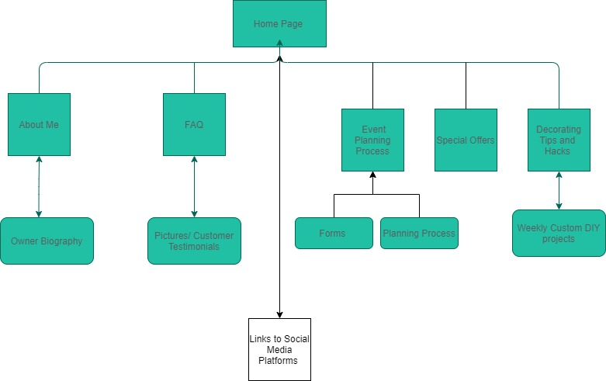

Each area on the website is broken down by function, then detailed sub-functions where needed. The main page will navigate to different sections with brief descriptions of each. Users can navigate using the fixed navigation bar that will allow easy navigation between pages. Also, the potential client/ client will be able to follow the links to the social media pages where they can connect to the business by getting the most up-to-date information regarding services and industry trends. Below are wireframe examples of the intended layout of the website.

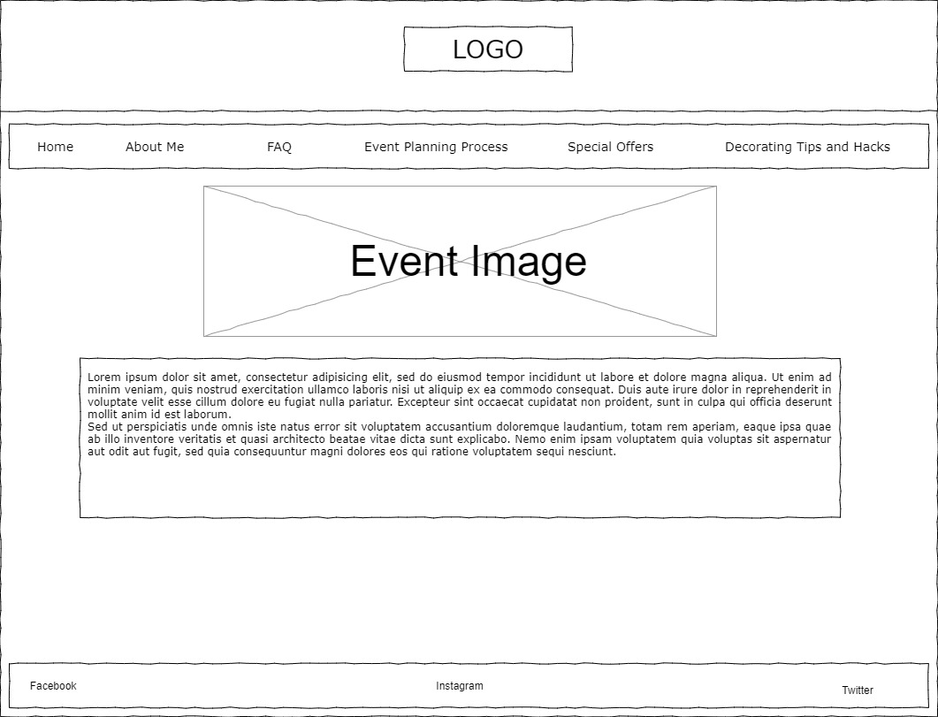

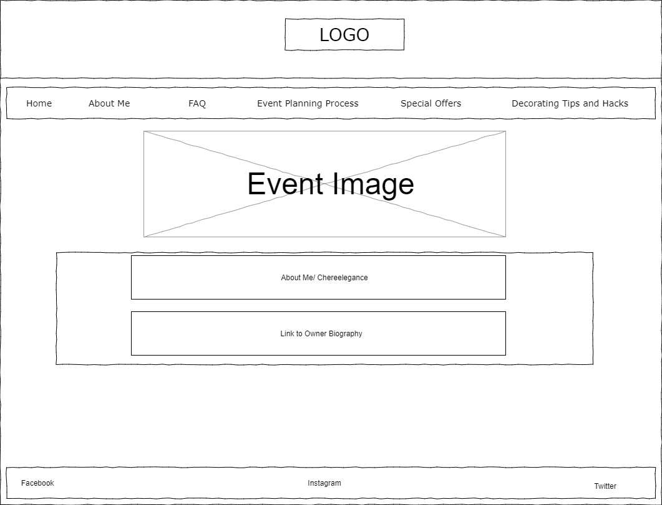

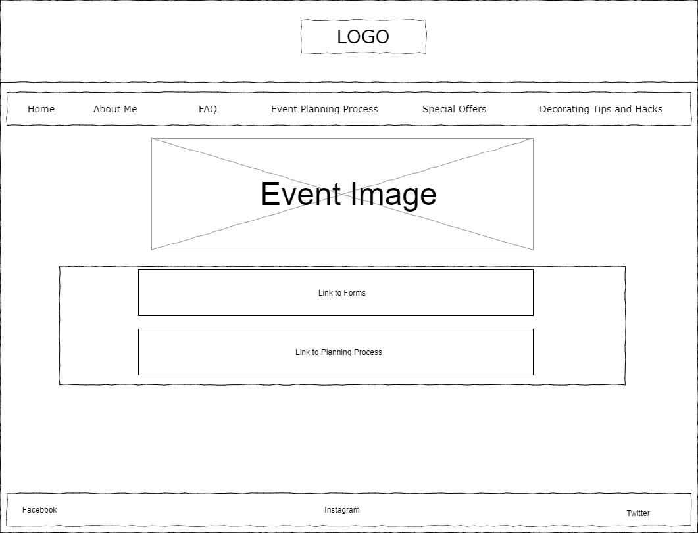

**SECURITY**

The website is intended to be informative so there will be no e-commerce, but I will have to reassess the security of my site when bookable services are added on the webpage. The website is to connect the customers to me and at that point, I will use my business account app through PayPal to accept payments. Finally, I can secure the webpage by hosting the page on a secure web host with SSL, creating backups for the site, and implementing custom error pages.

**WEB HOSTING**

The hosting of my web page will have to incorporate various factors that I will have to consider. Since my business is small, I will be interested in price and security. Those two factors will be my starting point for how I decide on a web host. Next, this website is for informational purposes so videos will be embedded from Youtube to highlight my company. I think a video from YouTube will help to provide a personalized experience to the customer. I will utilize my social media accounts for the majority of videos and pictures so that the website can remain simple and require little bandwidth. In the future when the company expands, I plan on integrating purchasing of consultation services on the site. From my previous experience building a website, I know that there are websites that would compare the different features of the various web hosting so I will have to look at my budget and see which work best for the current state of my company. Next, the website is intended to be informative it will need to be secured at an affordable price. The website will be secured using SSL. Having a secure site will be important to me and my potential clients since I know the importance of feeling secure when I surf the web. My website will comprise HTML, CSS, and possibly JavaScript. The HTML and CSS will be used to design the website. The JavaScript will be used later to collect user data for following-up with email and text. Cherelegance.net is the domain name that I selected since the website name matches my social media page and will make it easier for customers to be attracted to my site.

**MARKETING**

The website will be marketed using social media platforms and through QR codes at events that I decorate. Since this is a relatively new business, using social media marketing will help me to connect to individuals who see and like the work that I complete. This will allow me to reach the target audience with minimal effort. Social media platforms can also direct the target demographics towards my company. Additionally, I will use the word-of-mouth approach by adding QR codes throughout the event that I plan to provide individuals attending the opportunity to book me for their next event. The website will also be SEO Search Engine Optimization. The website will use target keywords, be well-formatted, uses internal and external links, and will adhere to the Google standards allowing the website to be easily searchable on the web.

**REFERENCES**

Colorlib. (2019, October 17). *17 Best Event Planner Websites Design To Unleash Creativity 2019*. https://colorlib.com/wp/event-planner-websites/

Priest, C. (2019, May 1). *Importance Of Web Security In The Web Development Stage*. CloudSecureTech. https://www.cloudsecuretech.com/web-security-no-longer-overlooked-web-development-stage/

Torres, A. (2019, December 3). *The 12 Top Websites for Event Planners to Get Inspired*. A. Torres. https://www.eventbrite.com/blog/websites-for-event-planners-ds00/